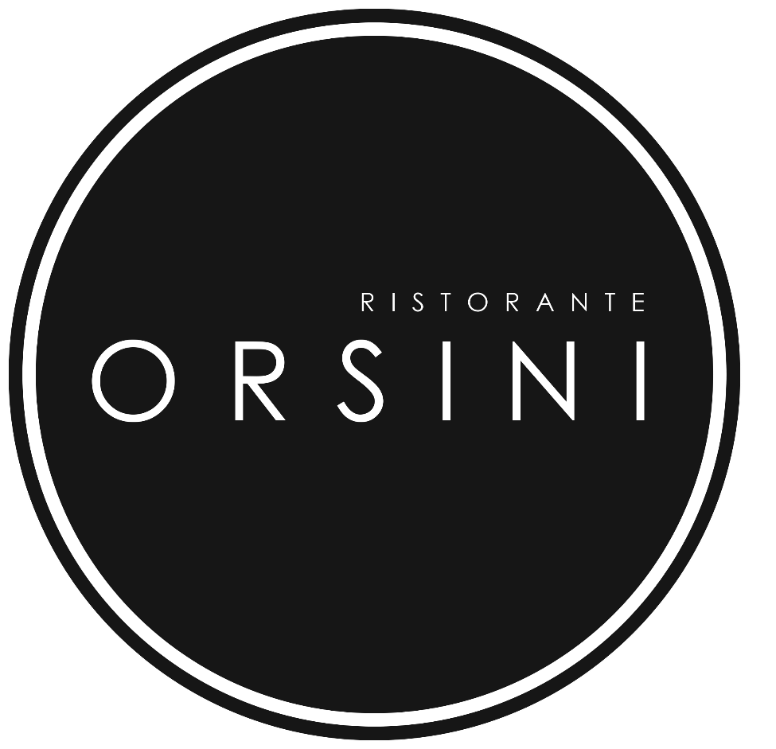

Orsini Menu
*Price may change to reflect market prices

*Antipasti (Appetizers) *Insalate (Salads) and Minestra (Soup)

Soup OF THE DAY $10.00 If Creamy $16

Bruschetta or Garlic Bread price per person $5

Caprese $16
(Bocconcino cheese, on vine ripened tomato steaks, onion ribbons, extra virgin olive oil sweet basil dressing)

Ceasar Salad $16
Crispy romaine lettuce tossed in a creamy garlic dressing with shaved Parmiggiano cheese

Mista Salad $16
Tossed fresh California greens with extra virgin olive oil and Modena’s balsamic dressing

Cozze Tarantina $16
Fresh cultivated steamed P.E.I. mussels, our chef’s way any day *White wine tomato sauce”

Calamari Fritti Fried tender Calamari rings OR Garlic Shrimp $16

*Pasta

** Add Meatball $5 Mushroom $3 Vegetable $5

Penne, Spaghetti, Linguine or Fettucine Tomato / Basil Sauce $19
Meat, Alfredo or Rosé Sauce $21

Lasagna Or Cannelloni Meat & Cheese filled (Allow up to 15 minutes please) $25

Manicotti Cheese and Spinach Filled homemade pasta roll $25

Gnocchi Your Way with Tomato Sauce $22
Meat, Alfredo or Rosé Sauce $23

Gnocchi Gorgonzola $25

Linguine & Shrimp $23
(Tiger and Baby Shrimp, fresh basil, zinfandel & creamy tomato sauce)

Linguine Portofino (One of our signature Sea Food Linguine) $29

*Main dishes * served with daily fresh vegetables OR Penne tomato sauce

Chicken or Veal Parmigiana (served with a side order of Penne Tom/Sauce) $22

Vitello Al Fungo (Veal scaloppini in mushroom Marsala sauce) $29

Vitello Margherita
(Veal scaloppini with Bocconcini cheese, light basil light basil demi-glace sauce) $29

Grilled Veal Medallion (for diet conscious) $27

Grilled Chicken Breast (for diet conscious) $27

Pollo Caprina (baked with caramelized onion and Goat Cheese) $35

Padella for two (Our long time signature dish) $75
A Seafood mix of Clams, Mussels, Calamari, Shrimp, Scallops, Crab leg pieces and extra-large Shrimp served with an order of Linguine and Baby Shrimp.

IF YOUR FAVOURITE DISH IS NOT LISTED, PLEASE ASK YOUR SERVER, WE MAY HAVE IT

